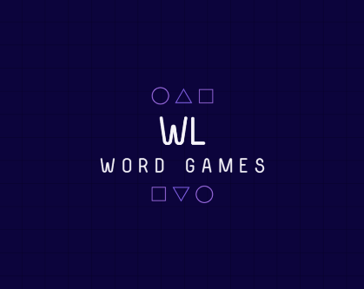

Documentation

Content

AUTHORS 2

SUMMARY 3

1. Aims 3

2. Stages of development 3

3. Realization 3

4. Allocation of tasks 3

CONCLUSION 3

# AUTHORS

|  |
| --- |
| Jasmina Valkova – Scrum Trainer – 9а |
| Bilyana Badalova - Backend Developer -9B |
| Viktoria Kupenova - Backеnd Developer -9G |
| Dimitar Georgiev - Quality Engineer- 9V |

# SUMMARY

## Aim

The idea for our project is to entertain and at the same time make people develop their thinking and learn new words.

## Stages of development

• Specifying the main purpose of the project;

• Dividing the project into major parts;

• Creating the idea of the game;

•Search information;

•Create reposytory;

•Code work;

•Code checks;

## Realization

Visual Studio was used to make the game. The game code is in The C++ language. After we decided what kind of game we were going to make and how it would be designed, I started writing the code. When I finished the game our team’s QA tested it. To make the code easier for understanding, I have written comments.

## Allocation of tasks

# Tasks were assigned to according to team roles. As in case of delay with a given task by a given team member, app description is also included.

# CONCLUSION

We have recreated a very old and interesting game into something new and stylish for the 21st century.